**Important Button Information**

**Large Button Costs**

|  |  |  |  |
| --- | --- | --- | --- |
| **Pinback Button** | **0.50** | **Strong Magnet** | **0.75** |
| **Weak Magnet** | **0.50** | **Keychain** | **0.75** |
|  |  | **Mirror Back** | **0.75** |

**Small Button Costs**

|  |  |  |  |
| --- | --- | --- | --- |
| **Pinback Button** | **0.50** | **Strong Magnet** | **0.75** |
|  |  | **Keychain** | **0.75** |

**\*\*\* Must sell buttons for more than what they cost to make a profit. Profit = Selling Price - Button Cost\*\*\***

**Hand In Requirements**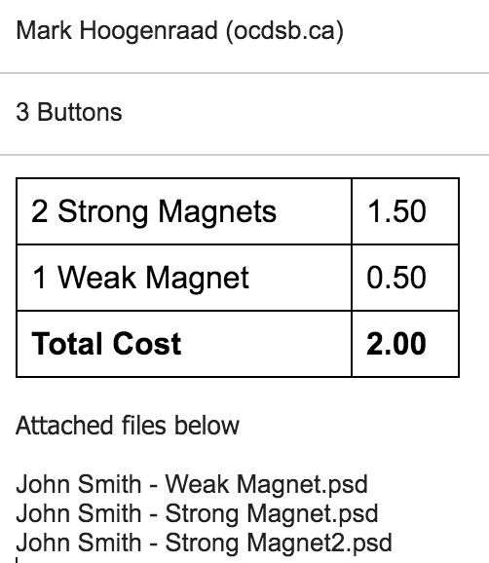

Name the file Your Name - Type of Button (Strong, Weak, Pinback, Mirror, Keychain).psd. Save as a photoshop file.

E-mail [mark.hoogenraad@ocdsb.ca](mailto:mark.hoogenraad@ocdsb.ca) and [jdang1@ocdsb.ca](mailto:julie.dang@ocdsb.ca) the file from your school account.

Include the **TOTAL COST** of your order in the e-mail.

**Example of E-Mail on the right ----->**

**Track All Sales**

**Example Table**

|  |  |  |  |  |
| --- | --- | --- | --- | --- |
| **Name of Customer** | **Button** | **Selling Price** | **Cost** | **Profit** |
| John Smith | Friends Strong Magnet | $5 | 0.75 | $4.25 |
| Pat Yu | Dog Weak Magnet | $2 | 0.50 | $1.50 |

**Copyright**

The onus is on you that you use copyright free pictures (Public Domain Pictures).

Use a website such as - <https://commons.wikimedia.org/wiki/Main_Page>

Or an option in BING search that searches Public Domain.